# DESIGN

Main

# Initialize scanner object

# Get input

# Prompt user for "Enter investment amount: "

# store value in a double (investmentAmount)

# Prompt user for "Enter annual interest rate in percentage: "

# store value in a double (annualPercentageRate)

# Prompt user for "Enter number of years: “

# store value in a double (numberOfYears)

# Initialize double FutureInvestmentValue

# Calculate FutureInvestmentValue as the result of:

# Original investment amount * (1+ monthlyPercentageRate)number of months

# monthlyPercentageRate is (annualPercentageRate/100)/12

# number of months = numberOfYears * 12

# Print “The future value is $” + futureInvestmentValue

# to format futureInvestmentValue, use String.format("%.2f", futureInvestmentValue)

## Flow Chart

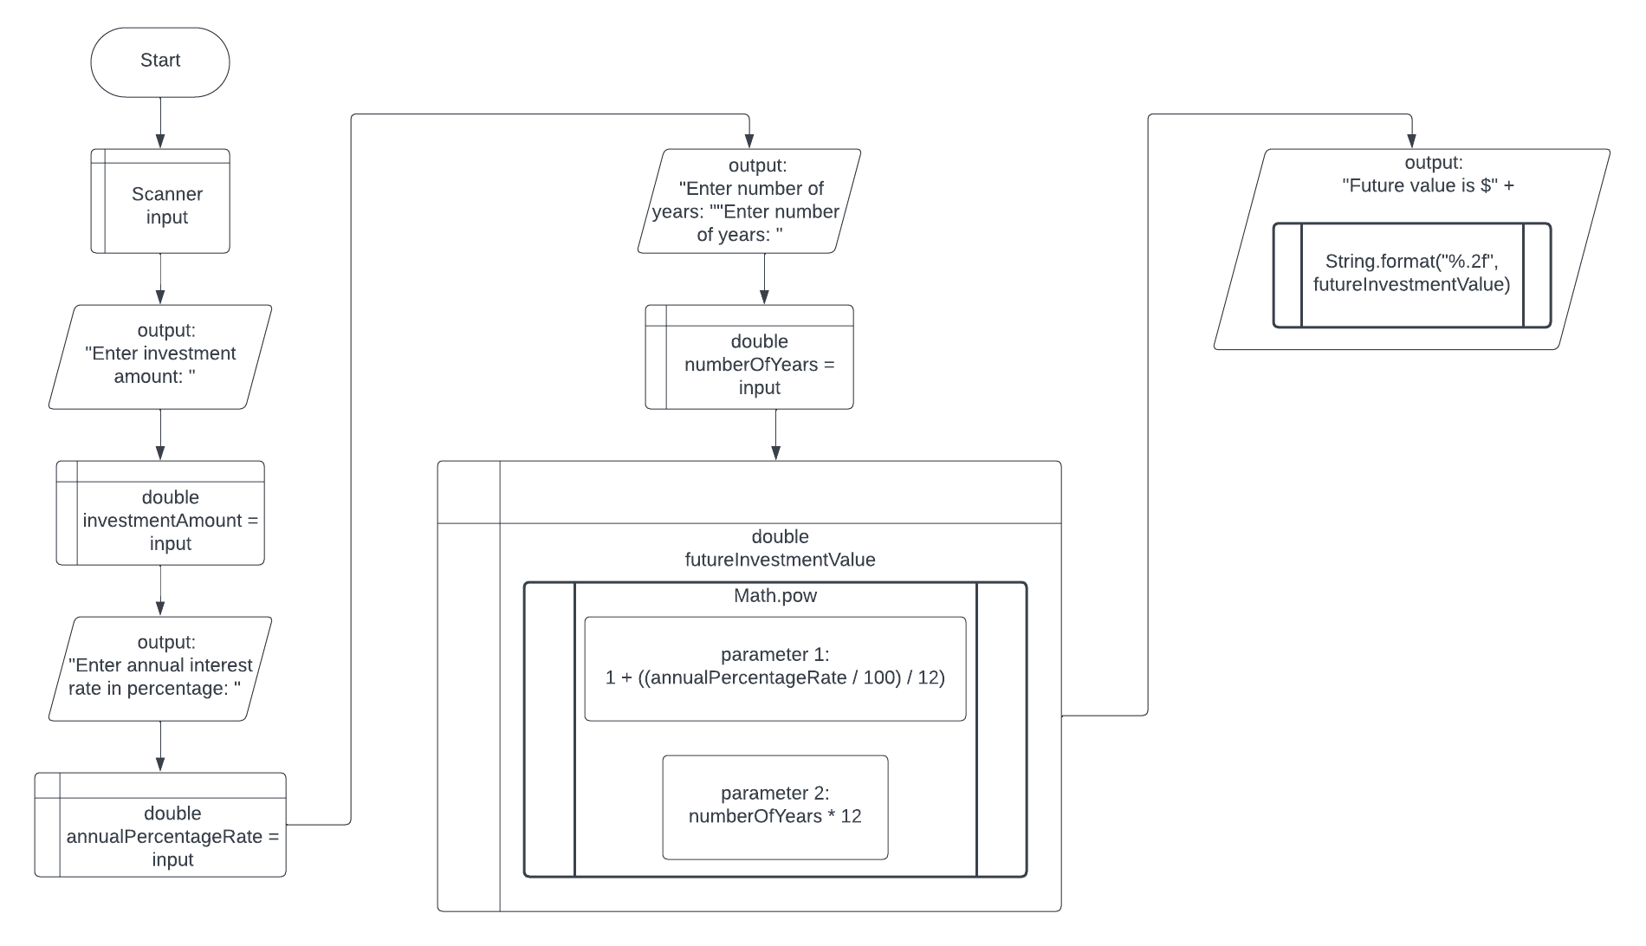

# TEST PLAN

|  |  |  |
| --- | --- | --- |
| Test # | Input | Expected Output |
| 1 | investment amount: 1234  annual interest rate in percentage: 5.44  number of years: 2 | 1375.50 |
| 2 | investment amount: 54321  annual interest rate in percentage: 3.14159  number of years: 10 | 74340.76 |
| 3 | investment amount: 25000  annual interest rate in percentage: 1.1101  number of years: 25 | 32992.25 |